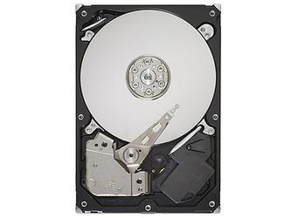

Seagate Barracuda 7200.11 1.5TB

Buying a little bit of extra storage is going to get tougher, soon. With drives like the Seagate Barracuda 7200.11 1.5TB only—and that includes a 5-year warranty—you may have to settle for a lot of storage. As you'd expect, at that price you'll have to accept some compromises. My applications-based testing using PCMark Vantage showed a small performance deficit compared with the numbers I got from high-end drives. But the Barracuda's transfer speed is fast, and the drive held its own on Media center, Vista startup, and application-loading tests. It'll also save you a bundle. For example, the Western Digital RE3 drive (WD1002FBYS) we tested against holds just 1TB, yet costs about $200. If you're looking to extend your hard drive capacity, this is a seriously cost-effective choice.

If you store all your data in the cloud, it might be hard to fathom an external hard drive doing double duty as a status symbol. That's exactly what the sleek, wildly fast, and eye-wateringly expensive Samsung Portable SSD X5 is, though. Following in the footsteps of both Samsung's own flagship external drives like the Portable SSD T5 and design-forward works of hard drive art from LaCie and others, the X5 offers copious amounts of solid-state storage at extreme speeds, thanks to its use of the cutting-edge Thunderbolt 3 and PCI Express NVMe interfaces. It would make a killer gift for Mac-bound video editors who shoot in 4K or photographers who work in RAW, but it's overkill for pretty much anyone else. If you store all your data in the cloud, it might be hard to fathom an external hard drive doing double duty as a status symbol. That's exactly what the sleek, wildly fast, and eye-wateringly expensive Samsung Portable SSD X5 is, though. Following in the footsteps of both Samsung's own flagship external drives like the Portable speeds, thanks to its use of the cutting-edge Thunderbolt 3 and PCI Express NVMe interfaces. It would make a killer gift for Mac-bound video editors who shoot in 4K or photographers who work in RAW, but it's overkill for pretty much anyone else.

SPEC DATA:

Type:
Internal

Storage Capacity (as Tested):
1.5 TB

Rotation Speed:
7200 rpm

Ports:
SATA

